TDR Homework (20 Points)
(jas, TDR HW.docx, 10/08/2025)

Use units and clearly label answers using 3 or 4 significant digits where appropriate. Show your work so that if necessary partial credit can be awarded.

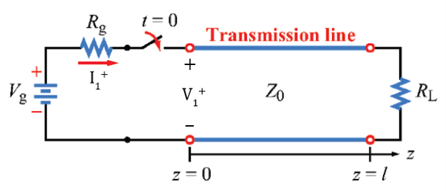
- For the adjacent circuit with V_{g} = 9 V, R_{g} = 75 Ω, Z₀ = 50 Ω, and R_{L} = 25 Ω. determine each of the following:

- Initial voltage $V_{1}^{+}$ at the generator terminals upon switch closure.
(2 points.)
$$V_{1}^{+}=I_{1}^{+}Z_{0}=\frac{V_{g}Z_{0}}{R_{g}+Z_{0}}=\frac{\left(9V\right)\left(50Ω\right)}{75Ω+50Ω}=3.6 V$$

- Initial current $I_{1}^{+}$ at the positive generator terminal upon switch closure. (2 points.)
$$I_{1}^{+}=\frac{V_{g}}{R_{g}+Z_{0}}=\frac{\left(9V\right)}{75Ω+50Ω}=72 mA$$

- Steady-state voltage V∞ at the generator terminals. (2 points.)
$$V_{∞}=\frac{V_{g}R_{L}}{R_{g}+R_{L}}=\frac{\left(9V\right)\left(25Ω\right)}{75Ω+25Ω}=2.25 V$$

- Steady-state current I∞ at the positive generator terminal. (2 points.)
$$I_{∞}=\frac{V_{∞}}{R_{L}}=\frac{2.25V}{25Ω}=90 mA$$

- Reflection coefficient at the generator. (2 points.)
$$Γ_{g}=\frac{R_{g}-Z_{0}}{R_{g}+Z_{0}}=\frac{75Ω-50Ω}{75Ω+50Ω}=0.2$$

- Reflection coefficient at the load. (2 points.)
$$Γ_{L}=\frac{R_{L}-Z_{0}}{R_{L}+Z_{0}}=\frac{25Ω-50Ω}{25Ω+50Ω}=-0.33$$

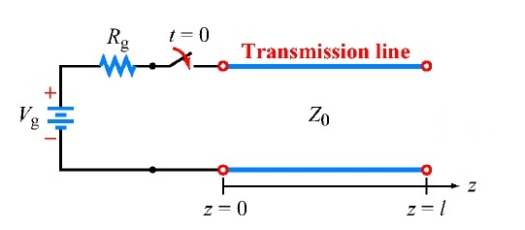
- The adjacent transmission line circuit has V_{g} = 12 V, R_{g} = 50 Ω, Z₀ = 50 Ω, and $Z_{L}=∞$.

- Complete the bounce diagram below starting at switch closure time t = 0. The time T on the bounce diagram equals l/u_{p}, where l is the length of the transmission line and u_{p} is the phase velocity along the transmission line. You can either add lines to the empty bounce diagram below using Insert → Shapes in Word or hand draw the lines, although your homework submission needs to be in electronic format. Include the voltage magnitude of each line displayed on your bounce diagram. (4 points.)

$$V_{1}^{+}=\frac{V_{g}Z_{0}}{R_{g}+Z_{0}}=\frac{\left(12V\right)\left(50Ω\right)}{50Ω+50Ω}=6 V$$
$$Γ_{g}=\frac{R_{g}-Z_{0}}{R_{g}+Z_{0}}=\frac{50Ω-50Ω}{50Ω+50Ω}=0$$
$$Γ_{L}=\frac{∞-Z_{0}}{∞+Z_{0}}=1$$
$$Bounce_{1}=V_{1}^{+}=6 V$$
$$Bounce_{2}=Γ_{L}V_{1}^{+}=1\left(6V\right)=6 V$$
$$Bounce_{3}=Γ_{g}Γ_{L}V_{1}^{+}=\left(0\right)\left(1\right)\left(6V\right) = 0V$$
*All other bounces will be multiplied by the reflection coefficient at the generator, which is zero. So, there are no bounces past the second line.*

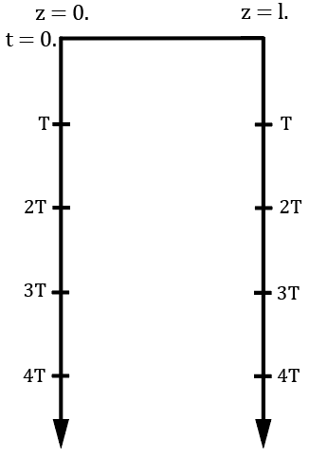
6V
6V

- From your bounce diagram, complete the following two voltage versus time graphs, starting at time t = 0. You can either add lines to the empty voltage versus time graphs below using Insert → Shapes in Word or hand draw the lines, although your homework submission needs to be in electronic format. (4 points.)

